Name: Class:
Introduction
An experiment was conducted to investigate the reaction between solutions of sulfuric acid (H₂SO₄) and barium hydroxide (Ba(OH)₂). The 0.20 mol L^{–1} Ba(OH)₂ solution was slowly added to 20.0 mL of the 0.15 mol L^{–1} H₂SO₄ solution, and the changes in electrical conductivity of the acid solution were recorded. The results are shown in the graph below.
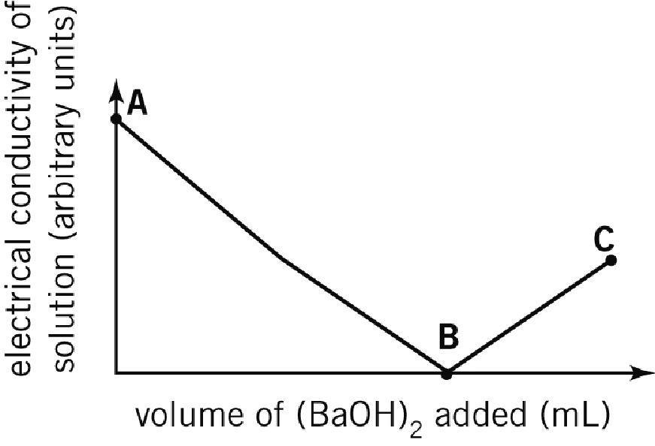

No. | Question | Answer
 | Write a balanced ionic equation for the reaction between H₂SO₄(aq) and Ba(OH)₂(aq).
 | Name any spectator ions in the reaction between H₂SO₄(aq) and Ba(OH)₂(aq).
 | What must a solution contain in order for it to conduct electricity?
At which point (A, B or C) shown on the graph is there the:
a greatest number of ions present in the solution?
b least number of ions present in the solution?
 | Explain why the conductivity of the solution decreases between points A and B on the graph.
 | Explain why the conductivity is at its minimum value at point B.
 | Explain why the conductivity of the solution increases between points B and C on the graph.
 | What volume of Ba(OH)₂ solution had been added at point B on the graph? Include any working used to obtain your answer.
 | Would you expect the same type of results graph to be obtained if the experiment was repeated using solutions of 0.15 mol L^{–1} H₂SO₄ and 0.20 mol L^{–1} NaOH? Explain your answer.

